Fonts

How to set-up Next.js Fonts

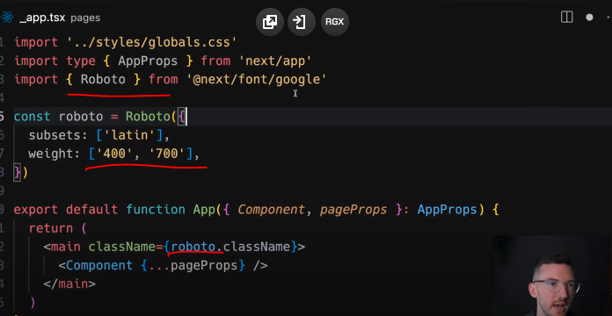

Localfonts

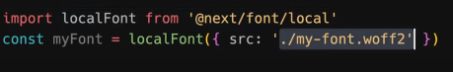

**Google Fonts**

Automatically self-host any Google Font. Fonts are included in the deployment and served from the same domain as your deployment. No requests are sent to Google by the browser.

Get started by importing the font you would like to use from next/font/google as a function. We recommend using variable fonts for the best performance and flexibility.

To use the font in all your pages, add it to _app.js file under /pages as shown below:

pages/_app.js

import { Inter } from 'next/font/google'

// If loading a variable font, you don't need to specify the font weight

const inter = Inter({ subsets: ['latin'] })

export default function MyApp({ Component, pageProps }) {

return (

<main className={inter.className}>

<Component {...pageProps} />

</main>

)

}

If you can't use a variable font, you will need to specify a weight:

pages/_app.js

import { Roboto } from 'next/font/google'

const roboto = Roboto({

weight: '400',

subsets: ['latin'],

})

export default function MyApp({ Component, pageProps }) {

return (

<main className={roboto.className}>

<Component {...pageProps} />

</main>

)

}

You can specify multiple weights and/or styles by using an array:

app/layout.js

const roboto = Roboto({

weight: ['400', '700'],

style: ['normal', 'italic'],

subsets: ['latin'],

display: 'swap',

})

Good to know: Use an underscore (_) for font names with multiple words. E.g. Roboto Mono should be imported as Roboto_Mono.

Apply the font in <head>

You can also use the font without a wrapper and className by injecting it inside the <head> as follows:

pages/_app.js

import { Inter } from 'next/font/google'

const inter = Inter({ subsets: ['latin'] })

export default function MyApp({ Component, pageProps }) {

return (

<>

<style jsx global>{`

html {

font-family: ${inter.style.fontFamily};

}

`}</style>

<Component {...pageProps} />

</>

)

}

**Single page usage**

To use the font on a single page, add it to the specific page as shown below:

pages/index.js

import { Inter } from 'next/font/google'

const inter = Inter({ subsets: ['latin'] })

export default function Home() {

return (

<div className={inter.className}>

<p>Hello World</p>

</div>

)

}

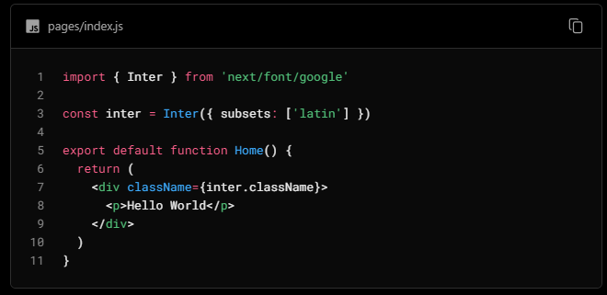

**Specifying a subset**

Google Fonts are automatically subset. This reduces the size of the font file and improves performance. You'll need to define which of these subsets you want to preload. Failing to specify any subsets while preload is true will result in a warning.

This can be done by adding it to the function call:

pages/_app.js

const inter = Inter({ subsets: ['latin'] })

View the Font API Reference for more information.

**Using Multiple Fonts**

You can import and use multiple fonts in your application. There are two approaches you can take.

The first approach is to create a utility function that exports a font, imports it, and applies its className where needed. This ensures the font is preloaded only when it's rendered:

app/fonts.ts

TypeScript

import { Inter, Roboto_Mono } from 'next/font/google'

export const inter = Inter({

subsets: ['latin'],

display: 'swap',

})

export const roboto_mono = Roboto_Mono({

subsets: ['latin'],

display: 'swap',

})

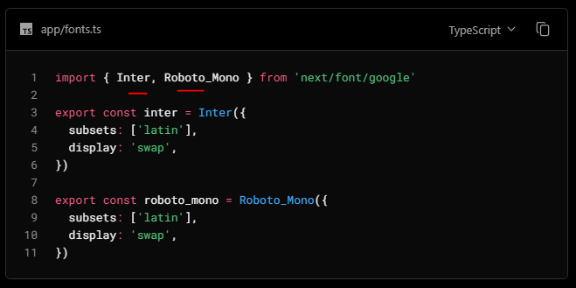

In the example above, Inter will be applied globally, and Roboto Mono can be imported and applied as needed.

Alternatively, you can create a CSS variable and use it with your preferred CSS solution:

app/global.css

html {

font-family: var(--font-inter);

}

h1 {

font-family: var(--font-roboto-mono);

}

In the example above, Inter will be applied globally, and any <h1> tags will be styled with Roboto Mono.

Recommendation: Use multiple fonts conservatively since each new font is an additional resource the client has to download.

Local Fonts

Import next/font/local and specify the src of your local font file. We recommend using variable fonts for the best performance and flexibility.

pages/_app.js

import localFont from 'next/font/local'

// Font files can be colocated inside of `pages`

const myFont = localFont({ src: './my-font.woff2' })

export default function MyApp({ Component, pageProps }) {

return (

<main className={myFont.className}>

<Component {...pageProps} />

</main>

)

}

If you want to use multiple files for a single font family, src can be an array:

const roboto = localFont({

src: [

{

path: './Roboto-Regular.woff2',

weight: '400',

style: 'normal',

},

{

path: './Roboto-Italic.woff2',

weight: '400',

style: 'italic',

},

{

path: './Roboto-Bold.woff2',

weight: '700',

style: 'normal',

},

{

path: './Roboto-BoldItalic.woff2',

weight: '700',

style: 'italic',

},

],

})

View the Font API Reference for more information.

**With Tailwind CSS**

next/font can be used with Tailwind CSS through a CSS variable.

In the example below, we use the font Inter from next/font/google (you can use any font from Google or Local Fonts). Load your font with the variable option to define your CSS variable name and assign it to inter. Then, use inter.variable to add the CSS variable to your HTML document.

pages/_app.js

import { Inter } from 'next/font/google'

const inter = Inter({

subsets: ['latin'],

variable: '--font-inter',

})

export default function MyApp({ Component, pageProps }) {

return (

<main className={`${inter.variable} font-sans`}>

<Component {...pageProps} />

</main>

)

}

Finally, add the CSS variable to your Tailwind CSS config:

tailwind.config.js

/** @type {import('tailwindcss').Config} */

module.exports = {

content: [

'./pages/**/*.{js,ts,jsx,tsx}',

'./components/**/*.{js,ts,jsx,tsx}',

'./app/**/*.{js,ts,jsx,tsx}',

],

theme: {

extend: {

fontFamily: {

sans: ['var(--font-inter)'],

mono: ['var(--font-roboto-mono)'],

},

},

},

plugins: [],

}

You can now use the font-sans and font-mono utility classes to apply the font to your elements.

**Preloading**

When a font function is called on a page of your site, it is not globally available and preloaded on all routes. Rather, the font is only preloaded on the related route/s based on the type of file where it is used:

if it's a unique page, it is preloaded on the unique route for that page

if it's in the custom App, it is preloaded on all the routes of the site under /pages

Reusing fonts